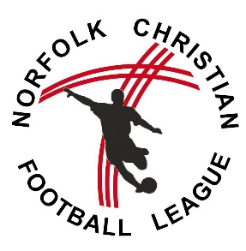
NCFL CLUB Affiliation Form: 2019/20 Season
FORM 1

We hereby seek affiliation to the Norfolk Christian Football League. We agree to abide by the rules and constitution of the League – in particular the Biblical Principles and Christian Ethics – and the decisions of the Management Committee.
PLEASE COMPLETE THE FORM CLEARLY AND IN BLOCK CAPITALS

 | Club details – 2019/20
Name of Club
Church/Club website:
Number of teams:
Contact Details | Club Secretary – 2019/20
Name:
Address:
Landline Tel:
Mobile:
Email:

 | Club Welfare Officer – 2019/20
Name:
Address:
Landline Tel:
Mobile:
Email:

Club Secretary Signature |  | Welfare Officer Signature

- The final deadline for NCFL affiliation is Saturday 29th June, 2019.
- In addition to this form – a TEAM affiliation must also be completed for each team in the league.
- Each form must include the signature of the Club Secretary and the Club Welfare Officer

By signing this form you are agreeing to the following communications. Please cross through if you do not agree.
- Receiving emails from the league - Receiving news emails from Network Norwich, website partner.
- Your contact details shared with other managers via the league contact list

