R
Form 4
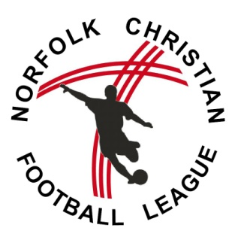
NCFL Mission Statement: 2016/17 Season

(Named Club) ________________________________________ Football Club

THE MISSION OF THE NORFOLK CHRISTIAN FOOTBALL LEAGUE

The Norfolk Christian Football League has been in existence since the late 1970s when a small group of churches decided to organise regular competitive football. Over the years the league has expanded and in the 1990s a Youth League was set up to provide Saturday morning football and has now grown to include football for Under 10s through to Under 16s.

The management of the league consists of a group of Christians from local churches and our strap line for the league is: ‘Connecting Church to Community through Football’

As Christians, we have a strong belief in the bible and what it tells us about Jesus – that He is God’s son - that He came to earth as a man – was put to death on a cross, but came back to life, having paid the penalty for the wrongdoings of the world – that He went back to heaven with his Father, God, and will return one-day to bring justice into the world. These events and beliefs help to shape our lives as Christians and part of our mission is to share God’s love for the world with others as it helps us to live life to the full and with greater purpose.

We recognise that many people connected with your team will not share these beliefs and we certainly welcome players of all faiths and those with no faith. But we also recognise that the local church is God’s representative in the community and has a role to play in sharing the Good News, supporting others and upholding Christian values. We therefore see the connection with the local church as being an important one.

How does this impact football?

We believe that playing football can be an expression of faith in God. A Psalm in the bible says, ‘I am fearfully and wonderfully made.’ The development of our skills – physically, mentally and socially – can all be part of a life of faith in God.

The bible also tells us that whatever we do, in word or deed, we should do for the glory of God.
(1 Corinthians 10 v 31)

In our football matches we offer the match to God in prayer at the start and we aim to honour God in the way it is played and in the way we interact with team mates, officials and spectators.

We totally support the FA guidance on RESPECT and encourage players, officials and supporters of both teams to see the match as an occasion to share fellowship together as well as taking part in competitive football. The code of conduct for all involved is detailed overleaf.

Thank you for taking the time to read our Mission Statement and code of conduct and we hope you will feel able to sign below to show you have understood our Mission.

Name of club secretary __ _ __ (signed) ______________________________

Name of church support ____________________________ (signed)____________________________

