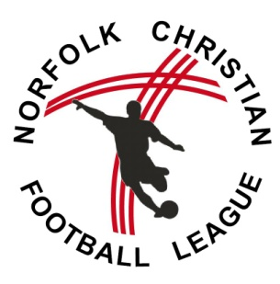
NCFL Code of Conduct: 2016/17 Season

Guiding Principles
We would request that all people present and involved in NCFL matches abide by the FA ‘Respect Code of Conduct’ and also by the biblical principle of the League (1 Corinthians 10 v 31) which states:
‘ Whatever you do, in word or deed, do it for the glory of God.’

This means that we expect everyone who is present at a match event, whether playing, managing, officiating or watching, to show respect through word and action to others at all times.

FA Guidance on ‘Respect’
The FA ‘Respect’ guidance states that respect stands for:
Referee is in charge
Encourage team-mates
Shout, but don’t criticise
Play fairly
Enjoy the game
Captain only speaks to the referee
Try, whatever the score

“Respect is the collective responsibility of everyone in football to create a fair, safe and enjoyable environment in which the game can take place. The main message of the Respect programme is that real and lasting change will come about not just through the intervention of the FA but from everyone in football taking collective responsibility to promote what is good in the game and deal with that which diminishes it.”

Spectators, Parents and Carers
“Spectators and parents/carers are requested to observe the following guidance at all times.
• Remember that children play for FUN.
• Applaud effort and good play as well as success
• Always Respect the match officials’ decisions
• Remain outside the field of play and within the ‘Spectators’ Area (where provided)
• Let the coach do their job and not confuse the players by telling them what to do
FORM 6
• Encourage the players to respect the opposition, referee and match officials
• Avoid criticising a player for making a mistake – mistakes are part of learning
• Never engage in, or tolerate, offensive, insulting, or abusive language or behaviour”
Players
“Players should understand that if they do not follow the Code, any/ all of the following actions may be taken by their club, County FA or The FA:
• Be required to apologise to my team-mates, the other team, referee or team manager
• Receive a formal warning from the coach or the club committee
• Be dropped or substituted
• Be suspended from training
• Be required to leave the club
In addition:
• The club, County FA or The FA may make the parent/carer aware of any infringements of the Code of Conduct
• The FA/County FA could impose a fine and suspension against the club

Should inappropriate behaviour and a breaking of the code of conduct continue then the NCFL rules shall be applied: players may receive a caution or red card and managers or spectators could be requested to leave the vicinity of the playing area.

For more information about ‘Respect’ visit http://www.thefa.com/RESPECT
Or speak to the NCFL Respect Officer

Signed in acceptance of the code of conduct
Club/team:
Name:
Date:
Signature:

