CELEBRATE NORWICH & NORFOLK - June 12, 2021

2020 has been a year of change on every level impacting the church and Christian ministry like never before. Who would have believed as we entered the year that before spring was out we would end up locked down by government decree? And more than that, the knock on consequences seem to be that the foundations of our society are being shaken.
It seems to me that Celebrate is needed more than ever. The people of God should be seen to be active in the public arena declaring hope at a time of great turmoil in society. What better way to show that the Lord is alive, relevant and active in today’s world than for the Body of Christ to be seen together, celebrating, demonstrating and communicating what God is doing even in tough times.
This year we have launched a whole new programme of events for autumn, and Christmas 2020, Easter as well as the summer Forum event in 2021.
Celebrate Young Leaders Conference 24th October 2020 at New Hope Christian Centre NR1 2HX.
God willing we are planning to impact the Norwich City Centre with carol singing on Saturday 19th December.
On Easter Saturday, 3rd April, we hope to bring a passion play to the heart of Norwich.
On June the 12th Celebrate event at the Forum.
You will find full details of all these events on our website, Facebook and Instagram.
You are warmly invited to participate in any and all of these initiatives.
Now is the time to begin our planning for the Forum event on 12th June 2021. You will find included with this letter the information you need to book your place. We look forward to our mutual fellowship as we stand together for Christ and the Kingdom.
We pray God’s riches blessing upon you and your ministry.
John Betts

Our venue

Celebrate Norwich & Norfolk is staged in one of Norwich’s most iconic venues, the stunning Forum and Millennium Plain.

The landmark Forum complex was built to mark the Millennium and is now one of Norwich’s most visited locations with over 2.5 million visitors every year.

Flooded with natural light, the spectacular Atrium is at the heart of Forum life and is the location for the main Celebrate exhibition. Every week, over 50,000 people visit the Atrium to see its exhibitions, city library, restaurants, tourist information centre and BBC studios.

The Forum can also offer other top quality locations for Celebrate exhibitors to stage add-on events such as seminars, breakfasts or film shows.

The Auditorium offers theatre-style tiered seating for 120 people plus state-of-the-art presentation and multi-media facilities.

The Forum is located in one of the busiest pedestrian areas in Norwich city centre, and surrounded by a series of welcoming, expansive and traffic-free public plains including the Forum Amphitheatre, Upper Millennium Plain and Theatre Plain, all of which are used by Celebrate and available to its exhibitors.

For more details visit: www.theforumnorwich.co.uk

The package we offer includes:
- A stand in the Forum Atrium venue, which attracts over 50,000 visitors a week, on Saturday 12 June.
- A 5cm x 6.5cms display advert (including your logo and web address) in the special 13,000 circulation Celebrate edition of the Christian newspaper Good News for Norwich & Norfolk (which is distributed via churches and inside the Norwich Evening News) before the event.
- A classified web listing on the Celebrate Norfolk website (part of Network Norfolk)
- Promotion of the event before and during it, plus activities to encourage visitors and passers-by from the Millennium Plain to drop-in.
- A pre-event preparation meeting to convey necessary information and help organisations make the most of the opportunity Celebrate presents

The cost to you will be a single £140 to cover the exhibition and the advertising package. Exhibitors outdoors on Millennium Plain are charged £80 and provide their own stands etc.
(suggested price increases)

There is an Early Bird discount of 10% for booking before end January 2021

Additional discounted advertising options are available in the Good News newspaper including an eighth of a page advert at just £120 or a quarter page at just £200.

Discounts are also available to exhibitors who book a series of adverts in other editions of the Good News for Norwich & Norfolk newspaper.

Once you have booked your place for the exhibition, one of the Good News team will contact you to discuss copy for your standard advert and outline the other discounted advertising options.

50 copies of the newspaper are given free to each advertiser for their own distribution/promotion.

Sample display ads in the newspaper

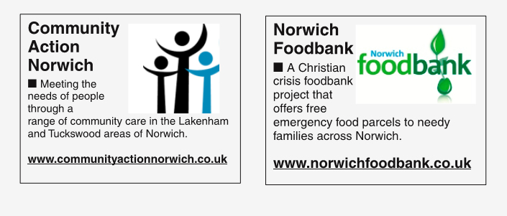

I look forward to hearing from you with your booking requests.

Yours sincerely

Jenny

Jenny Drake
Project Administrator

